Seaside HOA  newsletter | - July 15, 2019
  - Keep it short
Common questions
Q: When is the annual HOA meeting?
The annual meeting takes place on October 5th at 6:00pm
Q: How do I reserve the pavilion?
Visit our website at seaside.gogladly.com
Q: Where is parking allowed?
You can park on the south side of the street.
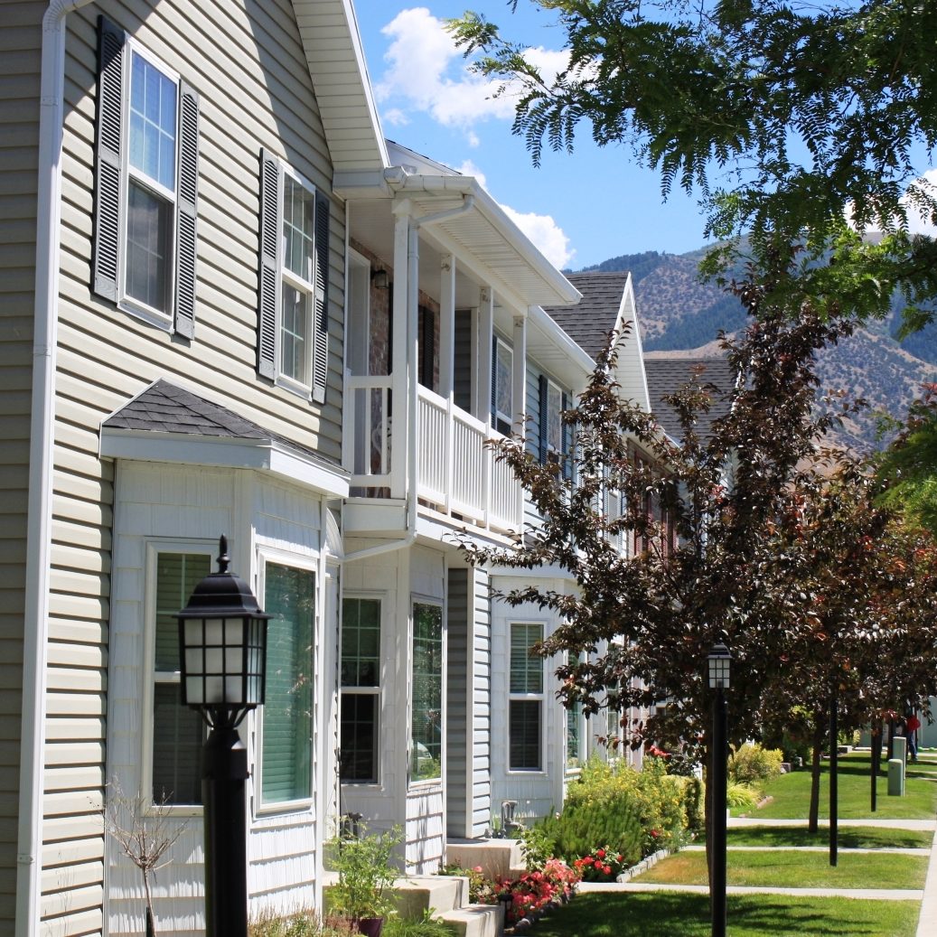
Tap here to add a caption

Contact Seaside HOA
seaside.gogladly.com
  - Use one page with 3-4 articles if you want residents to actually read the newsletter. According to the National Center for Biotechnology Information, the average customer’s attention span is 8 seconds, down from 12 seconds in 2000 (which is slightly more than the average attention span of a gold fish). How many people do you think will read a 4-page HOA newsletter? Not many.
“Call out an important point or date from your HOA community’s newsletter here”

give each article a headline

With online newsletters, 8 out of 10 people will read your headline, but only 2 out of 10 people will read the rest of your article. So, fit your message in the headlines. If you craft a good headline, you’ll increase the number of people that will actually read your content.

Give them some space

Don't cram your content into a single space with a 7 point font. This isn't an Econ 101 college essay with a page limit. Use a classic serif or classic sans serif serif font (like Times Roman or Calibri), 10-12 point paragraph text, 1.15 spacing, with double spacing between paragraphs. And PLEASE don't use comic sans.

More white space in your newsletter means less content, which translates to “only essential content", which places important information front and center.

Show them something
Include a photo or two in your HOA newsletter. Even if it's just a picture of your community, photos help increase engagement. A survey by HubSpot shows that 65% of respondents prefer emails newsletters that contain mostly images vs. 35% who prefer mostly text.
One marketing firm shows that articles with images get 94% more total views than articles without images. Get out your camera!

